HEATILE® GHOSTILE

**HIDDEN MODULAR RADIATOR TECHNICAL DATA SHEET**

**TENDER SPECIFICATIONS**

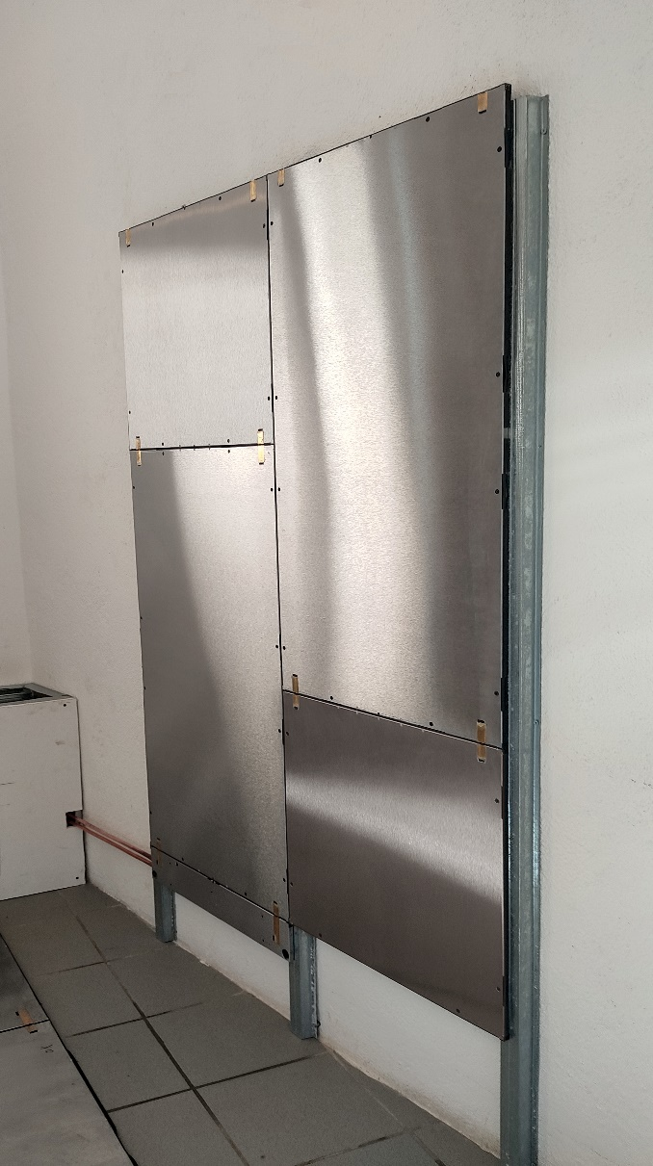Retractable modular hydronic radiator made with radiant panels in composite material. The modules are in dimensions of 60x60 cm or 60x120 cm with a thickness of 1.3 cm, composed of a structural panel with a steel surface, a copper circuit coil with brass quick couplings with hydraulic joints with multiple o-rings and a mechanical coupling system.

Thermal insulation is provided by a 1.1 cm thick 150 kg / m3 polyurethane layer (0.5 cm near the pipes) and a 40 kg / m3 thick neoprene compensation soundproof mat 0.02 cm with neoprene fractionation joints on each side of the module (every 60/120 cm).

**PRODUCT DESCRIPTION**

The radiant module is extremely light (12.5 Kg / m2), it is very thin (1.3 cm) and can be laid by anchoring it directly to the wall or to galvanized steel profiles for fixing substructures of dry construction systems ("omega" type for Knauf plasterboard mod. DX51D+Z-M/N-A-C).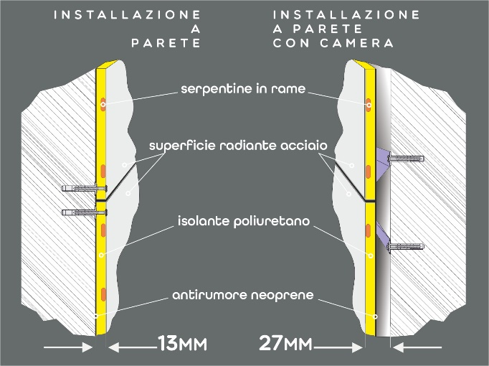

The radiant panels have the same thickness as common plasterboard and once installed they can be covered with covering materials such as stoneware, ceramic, plasterboard (glued like a stoneware tile) or smoothed by interposing a special mesh for smoothing.

The system combines extreme ease and speed of installation with exceptional yield thermal performance, which makes it extremely versatile, both in the recovery of old buildings and in new constructions.

The system is able to withstand operating temperatures up to 80 ° C at a maximum allowed pressure of 8 bar.

The Ghostile® hydronic radiator is connected to the system via the "H-Link" flush-to-the-wall connection system, interposing a lockshield valve system also with a servomotor for the thermoregulation of the rooms.

It is advisable to mount the degasser locally or in the boiler room to maintain the system.

Any additional layers of insulation and measures for noise abatement can be made under the Heatile® system.

Heatile® GHOSTILE

**HIDDEN MODULAR RADIATOR TECHNICAL DATA SHEET**

|  |  |  |
| --- | --- | --- |
| General features | | |
| Operating liquid |  | acqua |
| Total thickness | mm | 13 |
| Thickness of the steel radiant plate | mm | 1 |
| Insulation thickness (1) | mm | 11 |
| Copper pipe thickness | mm | 0,8 |
| Copper oval pipe section | mm | 7 x 18 |
| Density (polyurethane) | Kg/m3 | 150 |
| Resistance to vapor diffusion | μ | ∞ |
| Bottom side thermal insulation | W/mK | 0.022 |
| Maximum allowable pressure | bar | 8 |
| Operating temperature | °C | +5 / +80 |
| Coefficient of thermal expansion of steel | mm/m/ °C | 1,2 x 10-5 |
| Thermal conductivity of steel | W/mK | 60 |
| O’rings |  | EPDM perossidico 70 CG |

*(1) al di sotto del condotto di circuito 5 mm*

|  |  |  |  |  |  |  |
| --- | --- | --- | --- | --- | --- | --- |
|  |  |  | drywall | | GRES / PLASTER | |
| series | Number  forms | Dimensions  (mm) | low temperature  *watt (Δt 26°C)* | high temperature  *watt (Δt 50°C)* | low temperature  *watt (Δt 26°C)* | high temperature  *watt (Δt 50°C)* |
| LINEA 3 | 3 | 591 x 1875 | 341 | 658 | 374 | 722 |
| LINEA 4 | 4 | 591 x 2466 | 454 | 878 | 499 | 963 |
| QUADRA 4 | 4 | 1182 x 1284 | 454 | 878 | 499 | 963 |
| QUADRA 6 | 6 | 1182 x1875 | 682 | 1317 | 748 | 1445 |
| QUADRA 8 | 8 | 1182 x 2466 | 909 | 1756 | 998 | 1927 |
| QUADRA 12 | 12 | 1773 x 2466 | 1363 | 2633 | 1495 | 2890 |
| QUADRA 16 | 16 | 2364 x 2466 | 1818 | 3511 | 1995 | 3853 |

|  |  |  |  |  |
| --- | --- | --- | --- | --- |
| PRODUCER | Applicat. | PRIMER | ADHESIVE FOR COATING | GROUT FOR JOINTS |
| FASSA  BORTOLO | Gres | PRIMERTEK 101 | AZ 59 FLEX | FASSAFIL |
| KERAKOLL | Gres | KERAGRIP ECO | H40 NO LIMITS | FUGABELLA COLOR |
| MAPEI | Gres | ECO PRIM GRIP | KERAFLEX MAXI S1 | ULTRACOLOR PLUS |
| CHIMIVER | Legno | PRIMER Diluente APA | ADESIVER HERCULES | n.n. |
| MAPEI | Legno | ECO PRIM PU 1K | ULTRABOND ECO P909 2K PLUS | n.n. |

|  |  |  |  |  |
| --- | --- | --- | --- | --- |
| PRODUCER |  | PRIMER | RASANTE | Note |
| FASSA  BORTOLO | Rasante | PRIMERTEK 101 | K-OVER PLUS 3.30 | Rete  FASSANET MAXI |