HEATILE® GLA

**TECHNICAL DATA SHEET HYDRONIC SYSTEM WITH RADIANT PANELS FOR Raised FLOORS**

**TENDER SPECIFICATIONS**

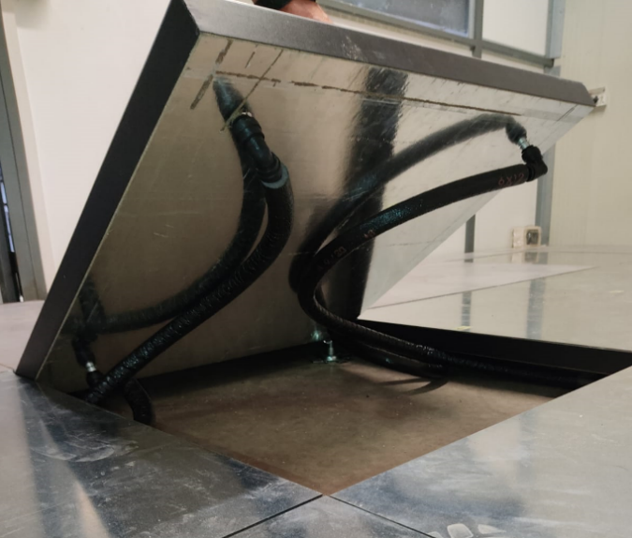Hydronic radiant panel measuring 60 x 60 cm with a thickness of 3.9 cm composed of a panel in wood conglomerate and high density thermosetting resins 700kg / m3 (with low formaldehyde E1 emission according to EN 717-1) with surface in steel and aluminum circuit coil AL 3103 with certified quick couplings and pre-insulated plastic pipes.

**PRODUCT DESCRIPTION**

The GLA series HEATILE radiant system combines extreme simplicity and speed of installation with exceptional thermal performance. The panels, laid on the classic supports for raised floors, are then coated with the most common covering materials (stoneware, ceramic, parquet, carpet, LVT, PVC, etc.).

The connections between the modules are made with certified quick couplings and pre-insulated plastic pipes that allow the lifting of the modules and the easy inspection of the underlying systems.

The materials used guarantee immediate reactivity while maintaining the characteristics of resistance to high mechanical loads intact.

Thermal insulation is given by the wood fiber. The system is able to withstand operating temperatures up to 65 ° C at a maximum pressure of 10 bar (at a temperature of 20 ° C).

Assembly instructions: approximately 4.32 m2 is the maximum surface area of ​​each single circuit (corresponding to 12 radiant modules) to be connected to the distribution manifold.

The system is installed directly on the classic supports for raised floors on a self-supporting substrate.

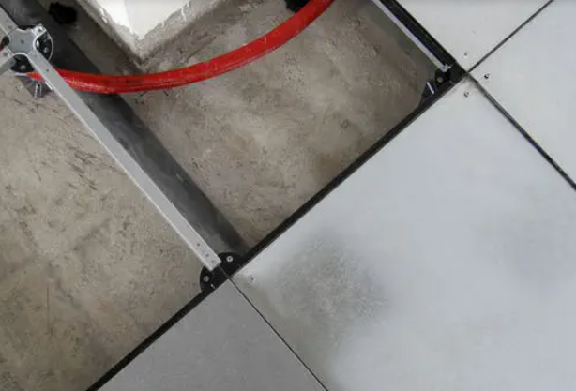 SIt is advisable to install degasser and filter for impurities in the boiler room (continue in the other page)

.

Heatile® gLA

**TECHNICAL DATA SHEET HYDRONIC SYSTEM WITH RADIANT PANELS FOR Raised FLOORS**

|  |  |  |
| --- | --- | --- |
| GENERAL DATA FORM | | |
| Operating liquid |  | Acqua |
| Total thickness | mm | 39 |
| Module size | mm | 600 x 600 |
| Effective module surface | m2 | 0.36 |

|  |  |  |
| --- | --- | --- |
| MODULE TECHNICAL DATA | | |
| DX51 steel radiant plate thickness | mm | 1 |
| Insulation thickness (1) | mm | 38 |
| Aluminum piping thickness | mm | 1 |
| Aluminum oval piping section | mm | 8 x 15 |
| Resistance to vapor diffusion | μ | ∞ |
| Bottom side thermal insulation | W/m2K | 1.99 |
| Fire resistance (2) |  | REI 30 FULL SCALE |
| Fire reaction class (3) |  | Classe 1 |
| Impact sound reduction (4) |  | ΔLW,P > 32 dB |
| Maximum allowable pressure | bar | 8 |
| Operating temperature | °C | +5 / +65 |
| Thermal expansion coefficient | mm/m/ °C | 1,2 x 10-5 |
| Thermal conductivity steel sheet DX51 | W/mK | 61 |

*(1) below the circuit duct 30 mm*

*(2) according to EN 1366-6*

*(3) according to UNI 8457 / UNI 9174*

*(4) according to ISO 140-8*

|  |  |  |  |  |
| --- | --- | --- | --- | --- |
| HEATING THERMAL EMISSION DATA (Without lining) | | | | |
| Thermal emission in heating  (Ambient temperature 20 ° C) | 125 W/m2  (Tm35/Tr28 °C) | 185 W/m2  (Tm40/Tr33 °C) | 245 W/m2  (Tm45/Tr38 °C) | 360 W/m2  (Tm55/Tr48 °C) |

*(Tm = Flow temperature; Tr = Return temperature)*

|  |  |  |
| --- | --- | --- |
| cooling THERMAL EMISSION DATA (Without lining) | | |
| Thermal emission in cooling  (ambient temperature 25 ° C) | 62 W/m2  (Tm18/Tr21 °C) | 108 W/m2  (Tm14/Tr17 °C) |

*(Tm = Flow temperature; Tr = Return temperature)*

|  |  |  |
| --- | --- | --- |
| TECHNICAL DATA ISOLATED PIPE | | |
| Connection tube material |  | LLDPE |
| Connection tube size | mm | 12 x 1,5 |
| Connection Pipe Insulation Thickness (5) | mm | 6 |
| Insulation pipe connection fire reaction class without C.F.C. |  | Classe 1 |

*(5) according to EN14313 0497 / CPR / 4697*