HEATILE® TECH
TECHNICAL DATA SHEET HYDRONIC SYSTEM WITH RADIANT PANELS

TENDER SPECIFICATIONS
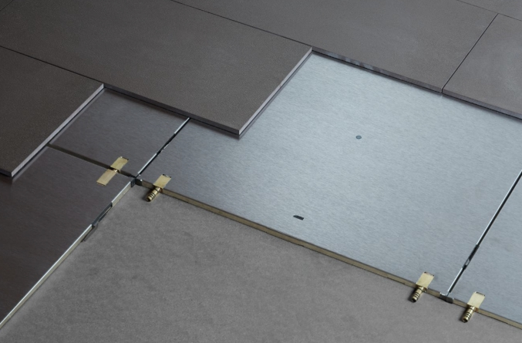
Hydronic system for dry radiant systems made with radiant panels in composite material. The modules are 59x59 cm or 59x118 cm with a thickness of 1.3 cm, composed of a structural panel with a steel surface, a copper circuit coil with brass quick couplings and multiple o-ring hydraulic couplings with system mechanical coupling.
Thermal insulation is provided by one layer of 1.1 cm thick 150 Kg / m3 polyurethane (0.5 cm near the pipes) and a 40 Kg / m3 soundproofing compensation mat in 0.02 cm thick neoprene with neoprene fractionation joints on each side of the module (every 60/120 cm).
PRODUCT DESCRIPTION
The radiant module is extremely light (12.5 Kg / m2) and very thin (1.3 cm).
The panels, laid directly on the screed or on the existing floors in case of renovation, can be covered with the most common covering materials (stoneware, ceramic, parquet, carpet, LVT, PVC, etc.). The system combines extreme ease and speed of installation with exceptional thermal performance, which makes it extremely versatile, both in the recovery of old buildings and in new constructions.

The configuration of the circuits of the systems is carried out with modules capable of interlocking with each other in all directions (with curved, straight modules, etc.) thus allowing to create very complex circuits and to satisfy the heating needs of any environment.
6.12 m2 is the indicative maximum area of ​​each single circuit (corresponding to approx. 17 modules) which can be split with the appropriate module. Heatile® TECH is connected to the manifold via the “H-Link” flush floor connection system or via multilayer pipe connections for long distances.
The system is installed after laying the underground utilities on a self-supporting substrate according to the specifications indicated below.
The system requires a smooth and level load-bearing substrate (discrepancies tolerated within 1.5 mm per linear meter), such as dry or granular screeds with wood fiber panels, leveled concrete screeds or existing floors.
Any additional layers of insulation and measures for noise abatement can be made under the Heatile® TECH system.
For overlapping installation with finishing materials, refer to the installation instructions.
It is recommended to mount degasser and magnetic dirt separator in the boiler room to maintain the system.

HEATILE® TECH
TECHNICAL DATA SHEET HYDRONIC SYSTEM WITH RADIANT PANELS

GENERAL DATA RADIANT MODULE
Operating liquid |  | Acqua
Total thickness | mm | 13
Actual single module size | mm | 591 x 591
Effective single module surface | m² | 0.35
Actual double module size | mm | 591 x 1178
Double module effective surface | m² | 0.70

TECHNICAL DATA RADIANT MODULE
Thickness of the steel radiant plate | mm | 1
Insulation thickness (1) | mm | 11
Copper pipe thickness | mm | 0,8
Copper oval pipe section | mm | 7 x 18
Density (polyurethane) | Kg/m³ | 150
Resistance to vapor diffusion | μ | ∞
Bottom side thermal insulation | W/mK | 0.022
Maximum allowable pressure | Bar | 8
Operating temperature | °C | +5 / +80
Coefficient of thermal expansion of steel | mm/m/ °C | 1,2 x 10⁻⁵
Fibrogesso thermal expansion coefficient | %/K | 0.001
Thermal conductivity of steel | W/mK | 60
Fiber gypsum thermal conductivity | W/mK | 0,32
O’rings |  | EPDM perossidico 70 CG
( ¹ ) al di sotto del condotto di circuito 5 mm
HEATING THERMAL EMISSION DATA (Without lining)
Thermal emission in heating  (Ambient temperature 20 ° C) | 117 W/m²  (Tm35/Tr28 °C) | 171 W/m²  (Tm40/Tr33 °C) | 225 W/m²  (Tm45/Tr38 °C) | 330 W/m²  (Tm55/Tr48 °C)
(Tm= Temperatura mandata; Tr= Temperatura ritorno)
cooling THERMAL EMISSION DATA (Without lining)
Thermal emission in cooling  (ambient temperature 25 ° C) | 56 W/m²  (Tm18/Tr21 °C) | 99 W/m²  (Tm14/Tr17 °C)
(Tm= Temperatura mandata; Tr= Temperatura ritorno)
COMPENSATION MODULE TECHNICAL DATA
Fermacell gypsum fiber | mm | 12,5
Gypsum fiber module size | mm | 600 x 1.000
Nominal density | mm | 1.150 ±50kg/m³
Brinnel hardness | N/mm² | 30
Thermal conductivity λ | W/mK | 0,32
Reaction to fire | EN13501-1 | A2-s1,d0
Thickness increase after 24h in water |  | < 2%

PRODUCER |  | PRIMER | COLLANTE PER RIVESTIMENTO | STUCCO PER FUGHE
KERAKOLL | Gres | KERAGRIP ECO | H40 NO LIMITS | FUGABELLA COLOR
MAPEI | Gres | ECO PRIM GRIP | KERAFLEX MAXI S1 | ULTRACOLOR PLUS
FASSA BORTOLO | Gres | PRIMERTEK 101 | AZ 59 FLEX | FASSAFIL

